

MINDMATE APPLICATION

together on a hope journey

Supervised by dr.emtithal

by : sarah fahad aljuaidi

Rana saad aldossary

shahad aldawood

muzon aldossary

1-WHAT IS MINDMATE APPLICATION ?

|  |
| --- |
| Description |
| mindmate application is an online platform that offers psychological consultation services through various means such as individual sessions. It aims to provide convenient and accessible mental health support to individuals seeking professional help. The background of the application is rooted in the increasing need for mental health services and the growing popularity of digital platforms for healthcare delivery. |
| WHAT OPPORTUNITIES AND PROBLEMS DOES THIS APPLICATION ADDRESS? |
| This application addresses several opportunities and problems in the field of mental health support , application addresses several opportunities and problems in the field of mental health support. Firstly, it provides a convenient and flexible way for individuals to access psychological consultation without the need for physical appointments, saving time and effort. it also allows for remote access, which is particularly beneficial for individuals living in remote areas or those with mobility limitations. Additionally, it offers a range of services including lectures and session, providing a broader range of support options for different n offers a range of services including lectures and session, providing a broader range of support options for different needs.eeds. However, it also presents challenges such as ensuring the quality and effectiveness of the online consultations and maintaining privacy and security of the users ' personal information. |
| WHO ARE THE KEY STAKEHOLDERS? |
| - Patient  - Licensed specialists  - bank  - develobe |

2-REQUIREMENTS GATHERING:

For requirements gathering, we choose interviews. Interviews with potential users, licensed specialists,and developers can help gather insights and understand the specific needs and expectations of each stakeholder group. Additionally, observations of existing mental health support processes, both online and offline, can provide firsthand insight into the challenges, limitations, and opportunities that can be addressed through the application.

3-FUNCTIONAL/ NON-FUNCTIONAL REQUIREMENTS

-Functional

1 : patient must be able to login

2 : patient must be able to schedule and have online session with licensed specialists

3 : Licensed specialists have the ability to provide online consultation

4 : Licensed specialists have the ability to deliver lectures, set availability

5 : Licensed specialists can access relevant user information securely

-non-functional

1: system should provide security and privacy to Ensuring the confidentiality of user data and maintaining a secure platform for interactions and storage of sensitive information.

2 : system also should provide Reliability and availability Providing a stable and reliable platform that is available for users at all times, with minimal downtime or disruptions.

3 : lastly system should provide Scalability which mean the system can handle a growing user base and increased demand for services without significant performance degradation.

4-USE CASE DIAGRAM:

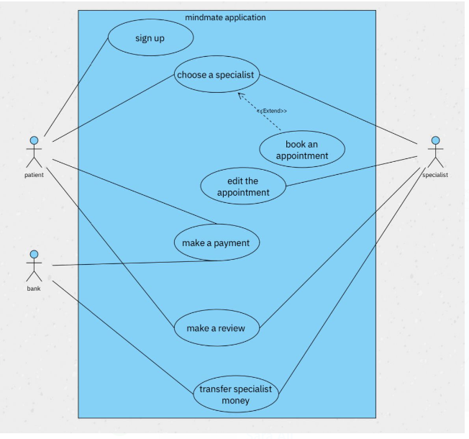

5-ACTIVITY DIAGRAM FOR LOGIN PROCCESS:

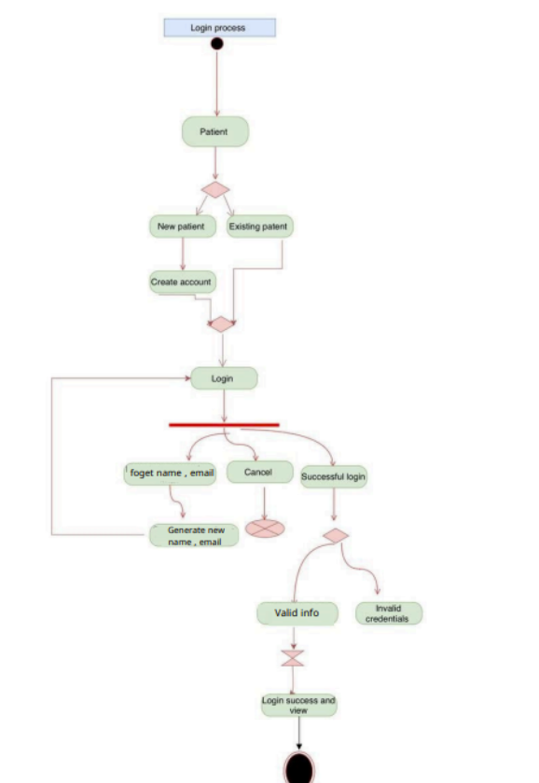

6-SEQUENCE DIAGRAM FOR LOGIN PROCCESS:

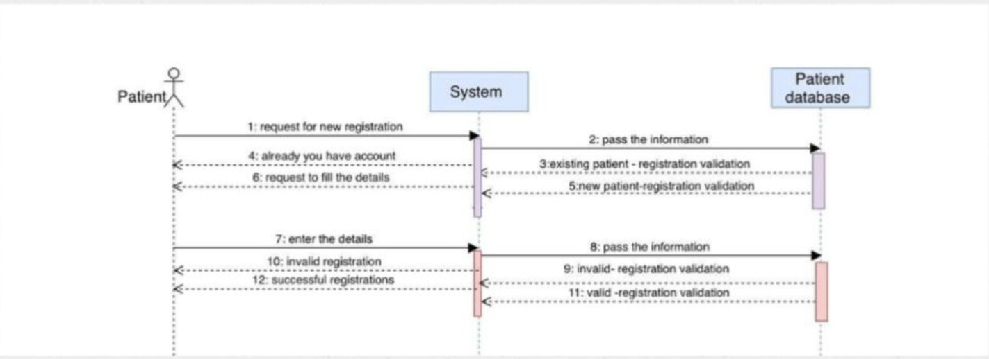

user interface: login page: service page:

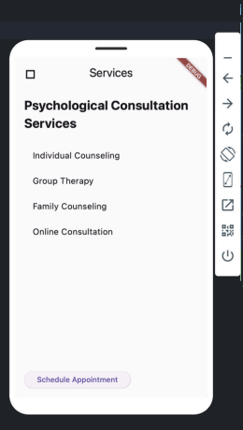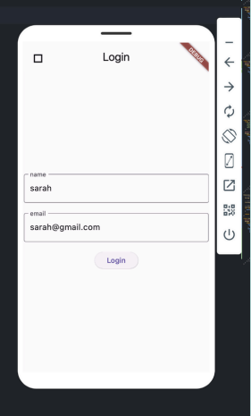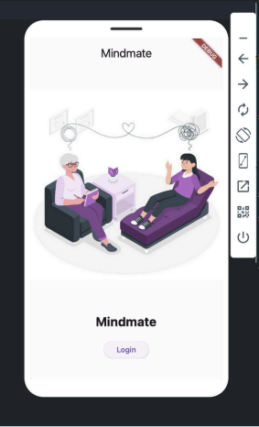

code path :

"C:\Users\ssooo\Downloads\Hello-World-2.zip"

Code details:

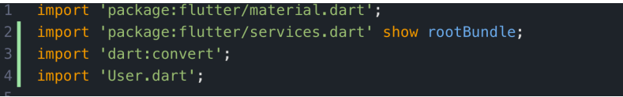

This section imports the necessary libraries for the Flutter application

. • flutter/material.dart: This library contains widgets implementing Material Design, which is a popular design language developed by Google.

• flutter/services.dart: It is specifically importing rootBundle from the Flutter services library. rootBundle provides access to the asset files of the application.

• dart:convert: This library is used for encoding and decoding JSON data.

• User.dart: It's assumed to be a custom class representing a user in the application.

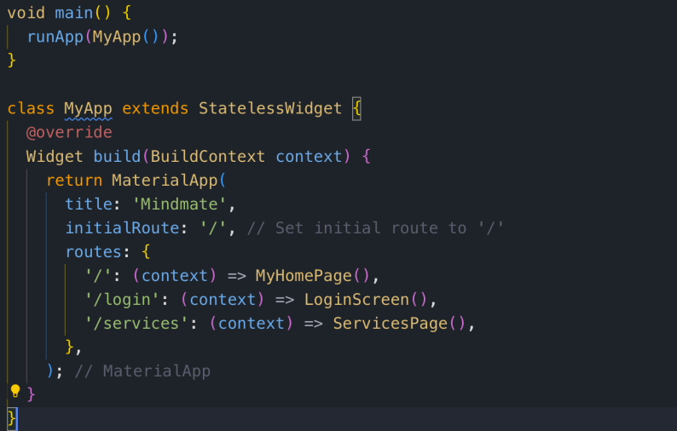

This is the entry point of the Flutter application. It calls the runApp() function, passing an instance of MyApp as its argument. MyApp is the root widget of the application MyApp is a stateless widget that represents the entire application. In its build() method, it returns a MaterialApp widget. MaterialApp is a widget that provides several important features, including the ability to define routes (routes), set the initial route (initialRoute), and manage the application's title (title). Routes are defined using a map where the key is the route's name (a string) and the value is a builder function that returns the corresponding widget for that route

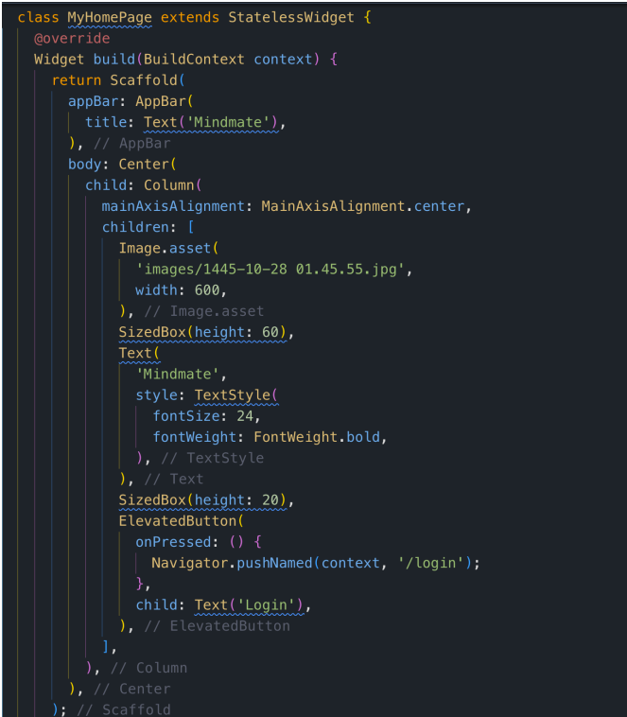

MyHomePage is a stateless widget that represents the home page of the application. It displays an AppBar with the title 'Mindmate', an image, and a 'Login' button. When the button is pressed, it navigates to the '/login' route.

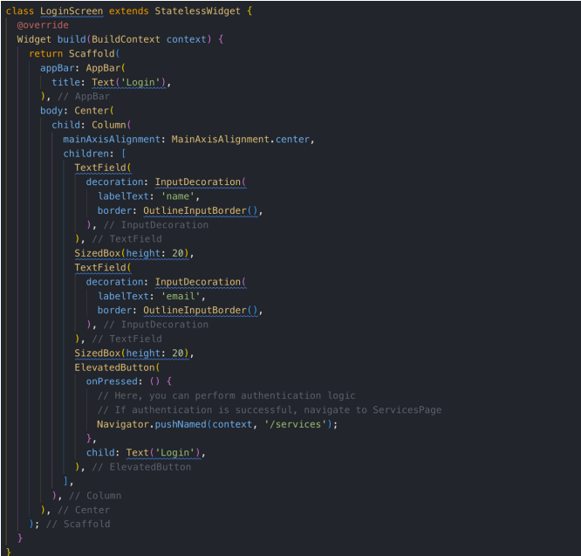

LoginScreen is another stateless widget representing the login page. It contains text fields for entering a name and email, along with a 'Login' button. When the button is pressed, it navigates to the '/services' route.

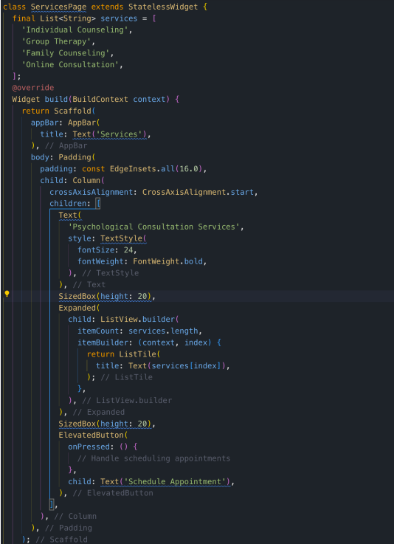

ServicesPage is a stateless widget representing the services page of the application. It displays a list of available services along with a button for scheduling appointments.

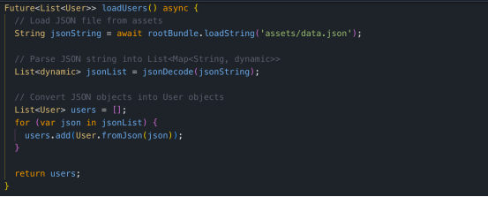

This function loadUsers() loads user data from a JSON file stored in the assets of the application. It returns a list of User objects parsed from the JSON data.

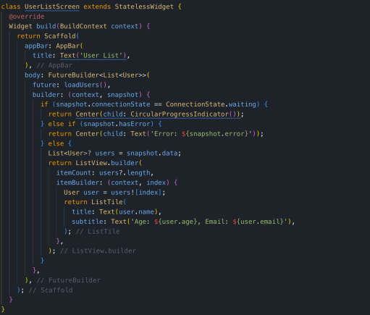

UserListScreen is a stateless widget that displays a list of users. It uses a FutureBuilder to asynchronously load user data and display a loading indicator while data is being fetched. Once the data is loaded, it displays a list of users with their names, ages, and emails.

This breakdown covers the entire code, explaining each component and its purpose in the Flutter application